# Racecar Test 1

Which of the following could be used to change actions based on a sensor reading?

A. Sequence

B. Selection

C. Iteration

D. Assignment

ANSWER: B

What is the difference between an analogue and digital reading?

A. Analogue readings can be understood by a computer whereas digital cannot

B. Analogue readings are continuous whereas digital are discrete

C. Analogue readings only have one state, 1 or 0 whereas digital have many different states

D. Analogue readings are manual whereas digital are automatic

ANSWER: B

What is the maximum value that the light sensor can detect on the bit:bit?

A. 0

B. 8

C. 1023

D. 1024

ANSWER: C

What type of code construct is the if statement in the code below?

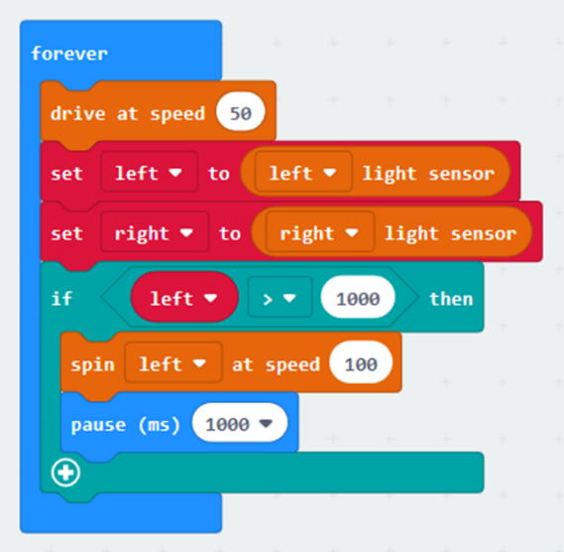

A. Selection

B. Sequence

C. Iteration

D. Assignment

ANSWER: A

Which of the following is a feature of a vector graphic?

A. It is made up of individual dots of colour called pixels

B. It can be resized with no loss of quality

C. It is a type of bitmap

D. It has a larger file size than a bitmap

ANSWER: B

What is mass production?

A. A cyclical design process

B. A way of making a one off product

C. The production of large quantities of standardised products

D. A type of prototyping

ANSWER: C

Which the following describes modular design?

A. Designing the whole system at the beginning so that it can be quickly implemented

B. A way of designing and refining the system until a final solution is developed

C. Splitting the overall system into a number of smaller parts which different people can work on

D. A type of 3D design

ANSWER: C

Which term is used to describe a self-driving vehicle?

A. Automatic

B. Intelligent

C. Autonomous

D. Algorithmic

ANSWER: C

What is the main purpose of testing?

A. To prove that something works

B. To try to identify any faults so that they can be fixed

C. To annoy programmers

D. To break the system

ANSWER: B

When creating a new race track it is first broken down into individual sections. What is this process known as?

A. Distribution

B. Decomposition

C. Abstraction

D. Development

ANSWER: B

Which of the following can be used to transmit data wirelessly?

A. Bluefinger

B. Bluetooth

C. Bluefoot

D. Cat 5

ANSWER: B

In which category will you find the commands to send data wirelessly?

A. Input

B. Logic

C. Radio

D. Variables

ANSWER: C

When transmitting data wirelessly from the micro:bit it is necessary to set the channel. How many different channels does the microbit have?

A. 83

B. 84

C. 1

D. 2

ANSWER: B

What number will be transmitted if directionTX is equal to 32?

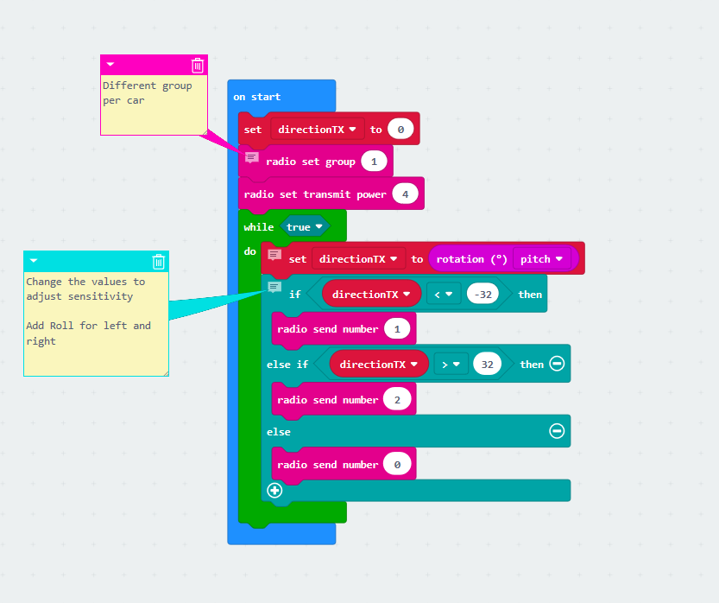

A. 0

B. 1

C. 2

D. 4

ANSWER: A

The code below has been created so that the bit:bot follows a torch light. Which value should be changed to adjust the sensitivity?

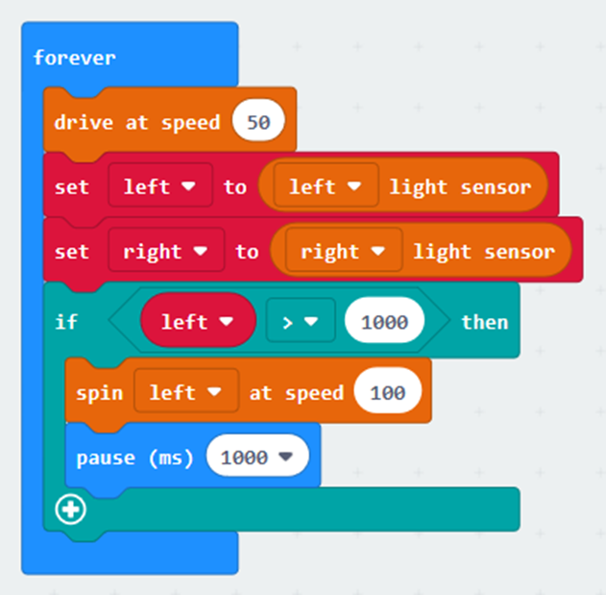

A. drive at speed 50

B. left > 1000

C. spin left at speed 100

D. pause (ms) 1000

ANSWER: B

Which of the following images is not a bitmap?

1. 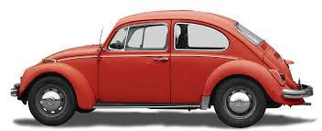
2. 
3. 
4. 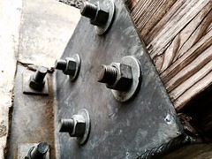

ANSWER: C

What is branding?

A. A type of approach to develop code

B. A way of removing unnecessary detail from a problem

C. A way of getting a business recognised

D. A type of image

ANSWER: C

What is prototyping?

A. An iterative development process

B. A method of mass production

C. A type of testing

D. A type of block programming

ANSWER: A

The code below has been written to initialise communication between two micro:bits. There is a fault with the code. How should it be fixed?

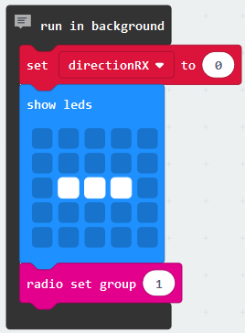Snippet 1

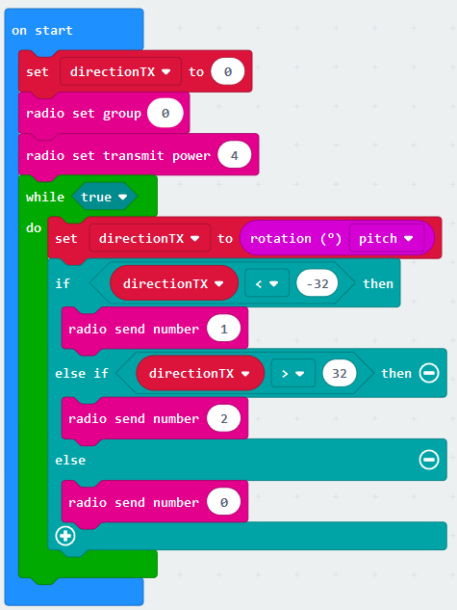Snippet 2

A. Change the radio set group to 1 in snippet 2

B. Change the radio set group to 2 in snippet 2

C. Increase the radio set transmit power to 10 in snippet 2

D. Decrease the radio set transmit power to 2 in snippet 2

ANSWER: A

The design below has been created for the manufacturing plant to follow. What is the name of this type of diagram?

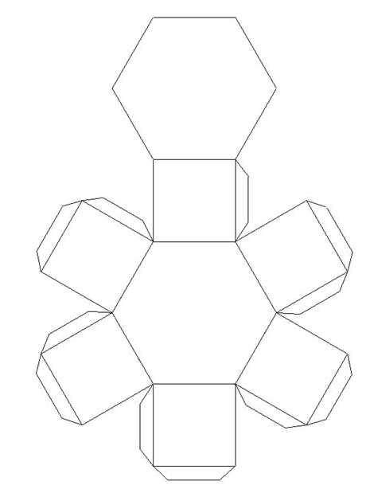

A. Web

B. Net

C. Mesh

D. Blackprint

ANSWER: B